**Architecture Design**

Airport Data Analysis

|  |  |
| --- | --- |
| Written By | Author 1, Author 2 |
| Document Version | 0.1 |
| Last Revised Date |  |

DOCUMENT CONTROL

Change Record:

|  |  |  |  |
| --- | --- | --- | --- |
| VERSION | DATE | AUTHOR | COMMENTS |
| 0.1 | 26-08-2022 | Sanjesh Chourasia | Introduction and architecture defined |
|  |  |  |  |
|  |  |  |  |
|  |  |  |  |

Reviews:

|  |  |  |  |
| --- | --- | --- | --- |
| VERSION | DATE | AUTHOR | COMMENTS |
|  |  |  |  |

Approval Status:

|  |  |  |  |  |
| --- | --- | --- | --- | --- |
| VERSION | REVIEW  DATE | REVIEWED BY | APPROVED BY | COMMENTS |
|  |  |  |  |  |

**Contents**

**1 Introduction** 3

**1.1 What is an Architecture design document?** 3

**1.2 Scope** 3

**2 Architecture** 4

**3 Deployment Description** 7

**3.1 Deployment options in Tableau** 7

# **1 Introduction**

## **1.1 What is an Architecture design document?**

Any software needs the architectural design to represent the design of the software. IEEE defines architectural design as “the process of defining a collection of hardware and software components and their interfaces to establish the framework for the development of a computer system.” The software that is built for computer-based systems can exhibit one of these many architectures.

Each style will describe a system category that consists of:

• A set of components (e.g.: a database, computational modules) that will perform a function required by the system.

• The set of connectors will help in coordination, communication, and cooperation between the components.

• Conditions that how components can be integrated to form the system.

• Semantic models that help the designer to understand the overall properties of the system.

## **1.2 Scope**

Architecture Design Document (ADD) is an architectural design process that follows a step-by-step refinement process. The process can be used for designing data structures, required software architecture, source code, and ultimately, performance algorithms. Overall, the design principles may be defined during requirement analysis and then refined during architectural design work.

# **2 Architecture**

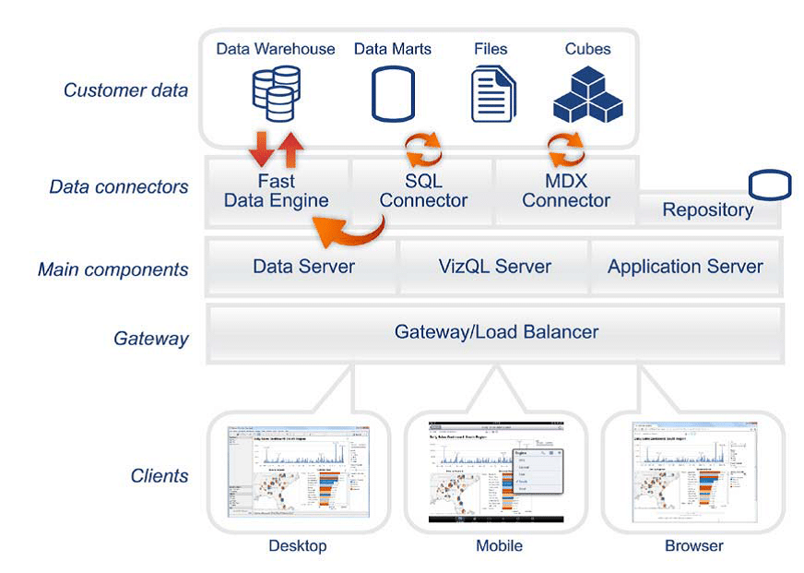

**Tableau Server Architecture**

Tableau Server is an important component in the Tableau architecture as it is thoughtfully designed to manage and execute crucial processes. It is important for us to understand what’s under the hood of Tableau Server as it is a core component and helps to understand Tableau better.  
Let us go through the components of Tableau Server and learn how they work.

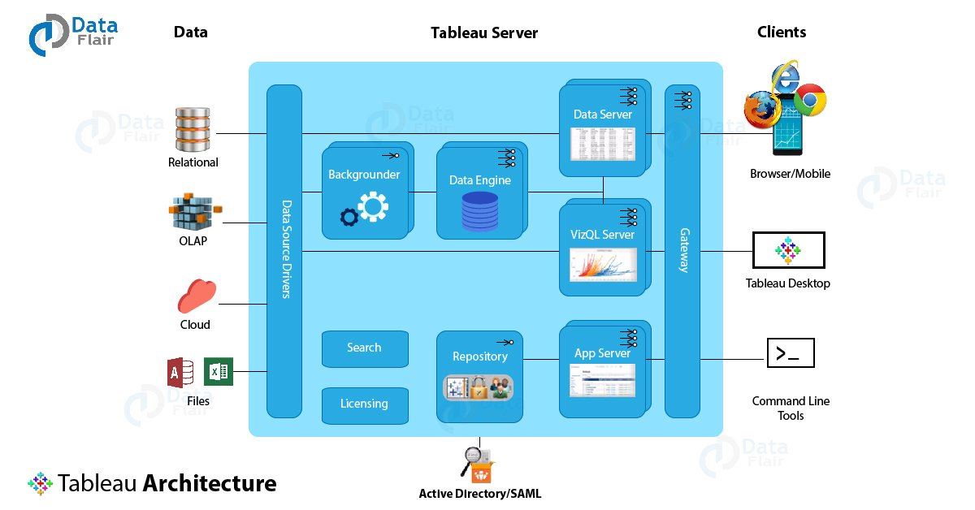

1. Gateway/Load Balancer

It acts as an Entry gate to the Tableau Server and also balances the load to the Server if multiple processes are configured.

2. Application Server: -

Application Server processes (wgserver.exe) handle browsing and permissions for the Tableau Server web and mobile interfaces. When a user opens a view on a client device, that user starts a session on Tableau Server. This means that an Application Server thread starts and checks the permissions for that user and that view.

3. Repository: -

Tableau Server Repository is a PostgreSQL database that stores server data. This data includes information about Tableau Server users, groups and group assignments, permissions, projects, data sources, and extract metadata and refresh information.

4. VIZQL Server: -

Once a view is opened, the client sends a request to the VizQL process (vizqlserver.exe). The VizQL process then sends queries directly to the data source, returning a result set that is rendered as images and presented to the user. Each VizQL Server has its own cache that can be shared across multiple users.

5. Data Engine: -

It Stores data extracts and answers queries.

6. Backgrounder: -

The backgrounder executes server tasks which include refreshing scheduled extracts, tasks

initiated from tabcmd and manages other background tasks.

7. Data Server: -

Data Server Manages connections to Tableau Server data sources. It also maintains metadata from Tableau Desktop, such as calculations, definitions, and groups.

8. Tableau Communication Flow: -

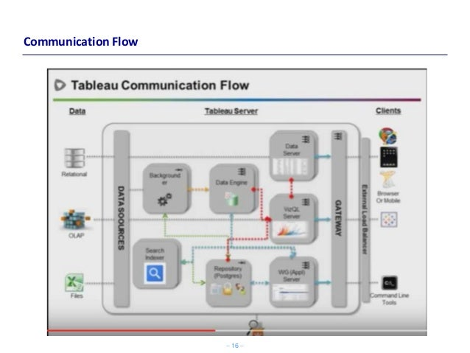

# **3 Deployment Description**

## **3.1 Deployment options in Tableau**

Tableau’s analytics platform offers three different deployment options depending on your environment and needs. The below graphic shows each option at a glance:

1. Tableau Online Get up and running quickly with no hardware required. Tableau Online is fully hosted by Tableau so all upgrades and maintenance are automatically managed for you.

2. Tableau Server deployed on public cloud: Leverage the flexibility and scalability of cloud infrastructure without giving up control. Deploy to Amazon Web Services, Google Cloud Platform or Microsoft Azure infrastructure to quickly get started with Tableau Server (on your choice of Windows or Linux). Bring your own license or purchase on your preferred marketplace.

3. Tableau Server deployed on-premises: Manage and scale your own hardware and software (whether Windows or Linux) as needed. Customize your deployment as you see fit.